# **Data Visualization using TreeMaps**

Please use the screenshots provided in the document as a reference only. The written instructions are provided for explicit direction.

PLEASE MAKE SURE YOU SUBMIT ALL THE SCREENSHOTS WITH TIMESTAMPS AT THE BOTTOM RIGHT (WINDOWS USERS) OR THE TOP RIGHT (MAC OSX USERS). THIS PROCESS ENSURES ASSIGNMENT INTEGRITY. SKIPPING THIS STEP QUALIFIES FOR DISCOUNTS.

### **Objective:**

The objective of this assignment is to visualize the university food court data using the TreeMap technique.

**Step 1: Data Loading**

1. Open the Tableau application.
2. Open the downloaded csv file using the *Text file* selection. Once you select the file click on “Open” button.  
     
   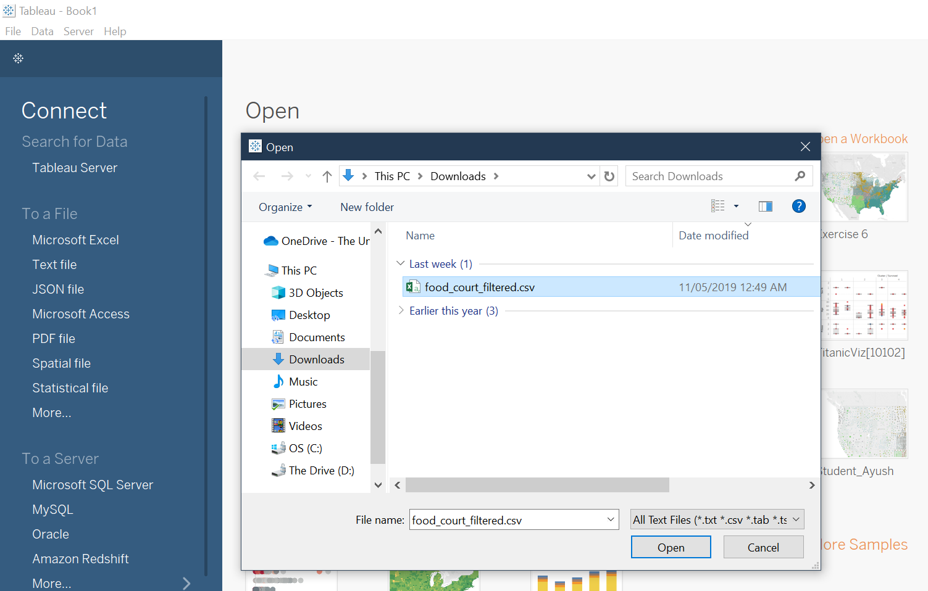

Question 1: Paste the full screenshot of your screen

Question 2: What are the total number of rows and columns displayed?

**Step 2: Analyzing the Net Sales of Stores**

1. Click on *Sheet1* at the bottom of your screen  
     
   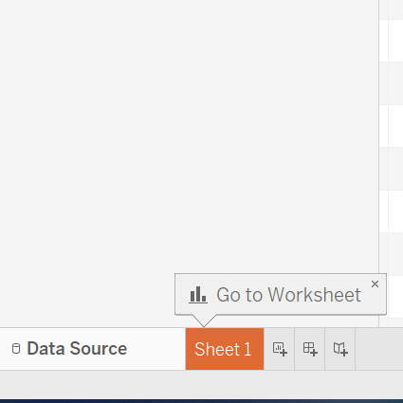
2. Drag *Store Name* and *Menu Item* to the columns shelf. Similarly, drag *Net Sales* to the rows shelf. The *SUM* manipulation is defaulted for the measure.  
     
   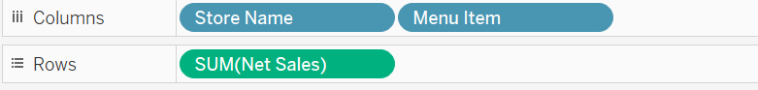
3. Change the *Standard* view to *Entire* view.  
     
   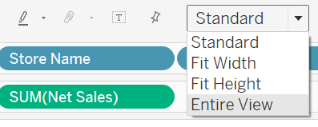
4. Right click on *Sheet1* in the navigation bar at the bottom and select the *Rename* menu path. Rename the sheet to *FirstName – NetSales vs Store*. (use your firstname)  
     
   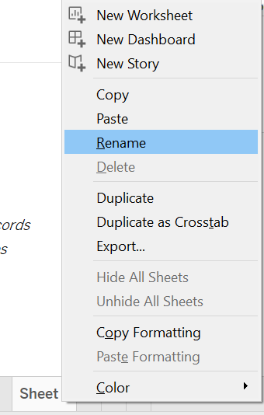

Question 3: Paste the screenshot of your full screen.

Question 4: What type of visualization is this?

1. Right click the down arrow on the *Menu Item* pill and select *Sort*.  
     
   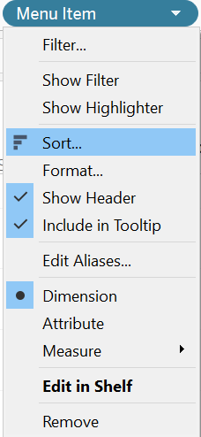
2. Maintain the *Net Sales* sort field as *Descending*.  
     
   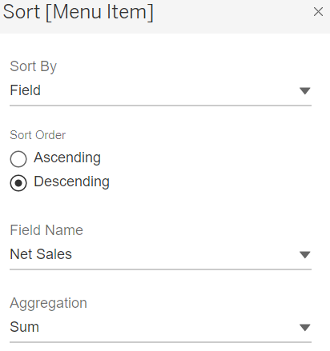
3. Repeat the same operation for *Store Name*.  
     
   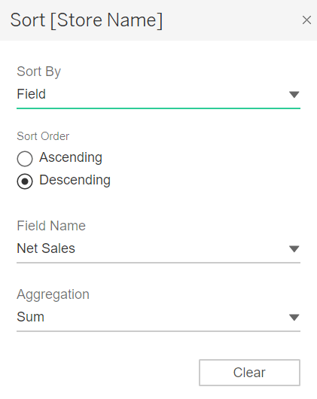

Question 5: Paste the full screenshot of your screen.

Question 6: What is the net sales value for *Café Mocha Large* in *Einsteins* store?

**Step 3: Creating a Store TreeMap**

1. Now click on the *New Worksheet* icon from the navigation bar at the bottom of the screen.  
     
   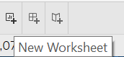
2. Now rename this sheet to *Store Treemap*.
3. Maintain the pills in the *Columns* and *Rows* as illustrated in the screenshot below.  
     
   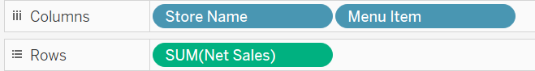
4. Click on the *Show Me* button at the top right of the screen and select *TreeMaps*.  
     
   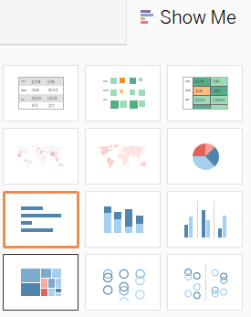
5. Click on the *Show Me* function again to hide it.
6. Remove *Net Sales* encoded with color by dragging it out from the Marks pane.  
     
   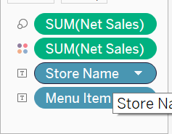
7. Drag *Store Name* to the *Color* Marks encoding the measure with color.  
     
   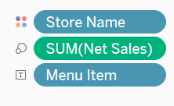
8. Change the view from *Standard* to *Entire* view.

Question 7: Paste the full screenshot of your screen.

Question 8: Which store appears to have the largest *Net Sales*?

**Step 4: Analyzing the Coffee Store/Papa John**

1. Create a new worksheet and rename it *Coffee Store/Papa John*.
2. Drag *Store Name* to the Filter shelf and select the checkbox for *Coffee Store/Papa John* as illustrated in the screen shot below. Click the *OK* button.  
     
   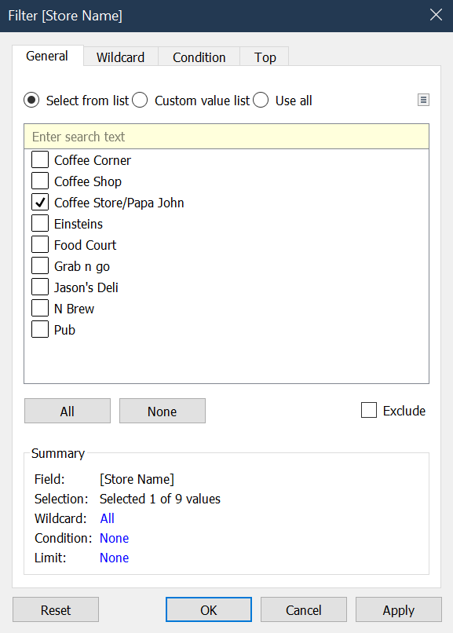
3. Drag *Net Sales* and *Menu Item* to the appropriate Marks in the Marks shelf. Maintain encoding for these variables as illustrated in the screen shot below.  
     
   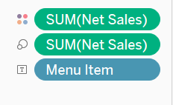

Question 9: Paste the full screenshot of your screen.

Question 10: What are the *Net Sales* for *bev-Dasani*?

**Step 5: Analyzing the Pub**

1. Create a new worksheet and rename it to *Pub*.
2. Drag *Store Name* to the Filters shelf and select *Pub* as highlighted below. Click on the *OK* button.  
   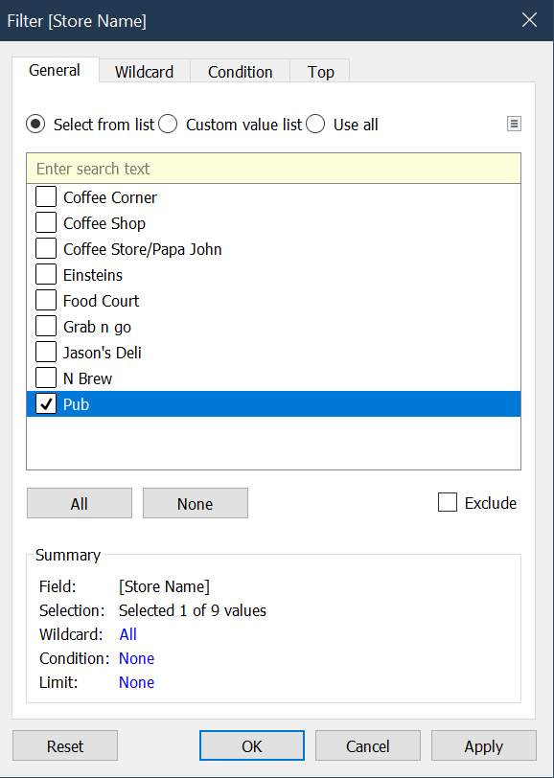
3. Drag *Net Sales* and *Menu Item* to the Marks shelf. Encode the data elements as defined in the screenshot below.  
     
   
4. Click on the down arrow next to the *Net Sales* legend.  
     
   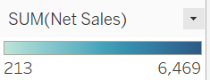
5. Select the *Edit Colors* menu.

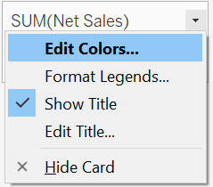

1. From the color palette select *Orange* then click on the *OK* button.  
     
   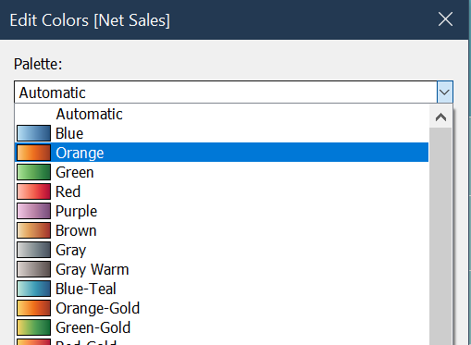

Question 11: Paste the full screenshot of your screen

Question 12: What is the net sales for “T-hot Mocha”?

**Step 6: Comparing Pub with Coffee Store/Papa John**

1. Click on the *Dashboard* icon in the navigation bar at the bottom of the screen and rename it to *Pub Vs Papa John*.  
     
   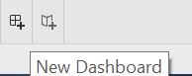
2. Go back to *Pub* and *Coffee Store/Papa John* sheets and change the view from *Standard* to *Entire* view.
3. Drag the *Pub* and *Coffee Store/Papa John* sheets to the dashboard canvas.

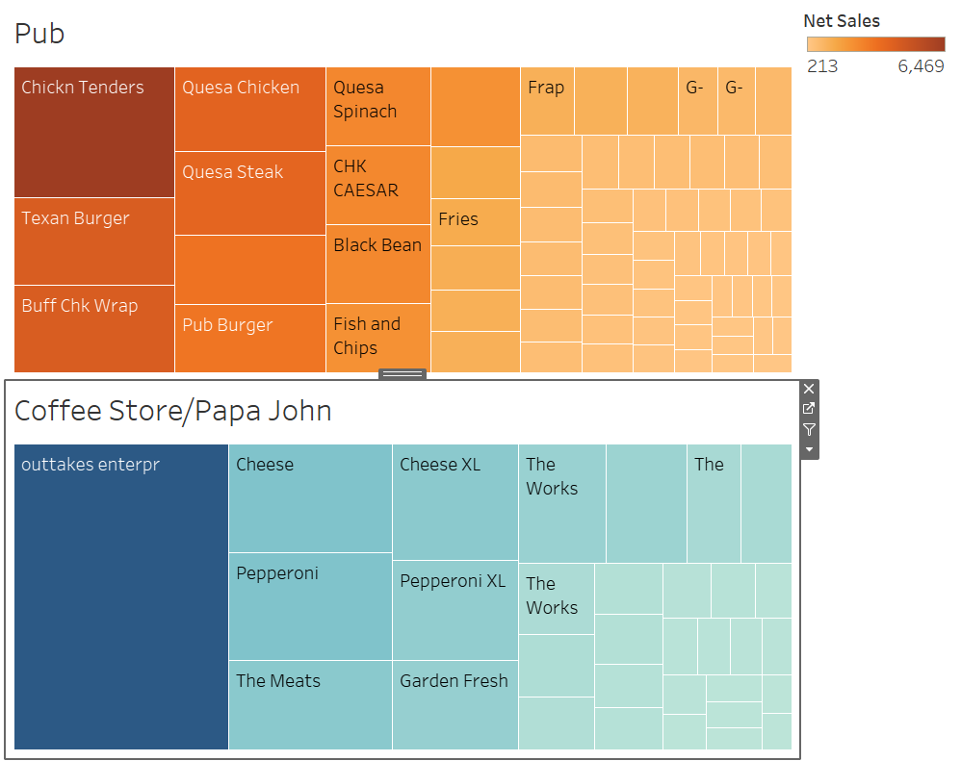

1. Click on the *Coffee Store/Papa John* sheet, then click on the down arrow as shown below.  
     
   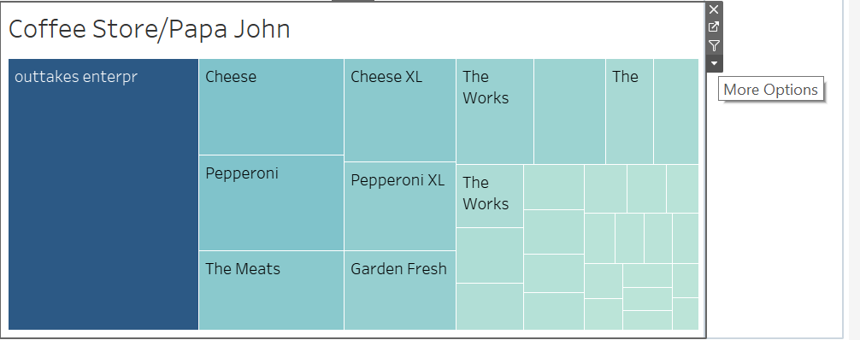
2. From the options, select the menu *Legends -> Color Legend (Net Sales)* as shown below.  
     
   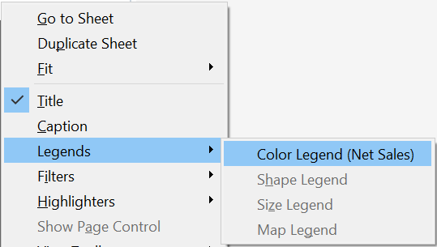
3. Adjust the legend to align with the *Coffee Store/Papa John* sheet.

Question 13: Paste the full screenshot of your screen.

Question 14: How does *Texan Burger* compare to *Cheese*?

Question 15: Please list the Top 3 products with values in terms of *Revenue* for the *Pub* and the *Coffee Store/Papa John*?

**Step 7: Creating a Story**

1. Click on new story icon and rename it to *Treemaps*.  
     
   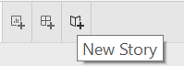
2. Drag the *Net Sales vs Store* analysis sheet to the story pane.
3. Provide an appropriate caption.
4. Click on *Blank* to add a new story point.  
     
   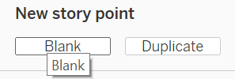
5. Drag *Store Treemap* to the story pane and give an appropriate caption for this story point.
6. Add the remaining 2 analysis sheets and the dashboard maintaining appropriate captions for each story point.

Question 13: Paste the screenshot of your screen, ensure that all story points are visible.

1. Save the tableau file as TWBX from File menu at the top left.

**Attach assignments in eLearning**

1. Attach the **assignment document (only answers to questions)** in Microsoft Word.
2. Submit the Tableau file (TWBX) only.